**MCDSS Lab 2 -Dataviz Decision Deck**

**Cole MacLean**

**February 26, 2016**

**Original Hotel List**

Using the original hotels, category scores and weights results in hotel NovetelCentrum being the optimal hotel to stay at for the conference in Poland.

Hotels and Weight Data

|  |  |  |  |  |
| --- | --- | --- | --- | --- |
| **Hotel** | **Location** | **Stars** | **Facilities** | **Restaurant** |
| Poznanzki | 0 | 0.9 | 0.2 | 0.8 |
| Traffic | 0.7 | 0.6 | 0.7 | 0.1 |
| NovotelCentrum | 1 | 0.7 | 1 | 1 |
| DonPrestige | 1 | 0.1 | 0.8 | 0.3 |
| Forza | 0.2 | 0.9 | 0.7 | 0.8 |
| PoznanClassApartm | 1 | 0.1 | 0.5 | 0.5 |
| **Weights** | **0.4** | **0.1** | **0.4** | **0.1** |

Workflow

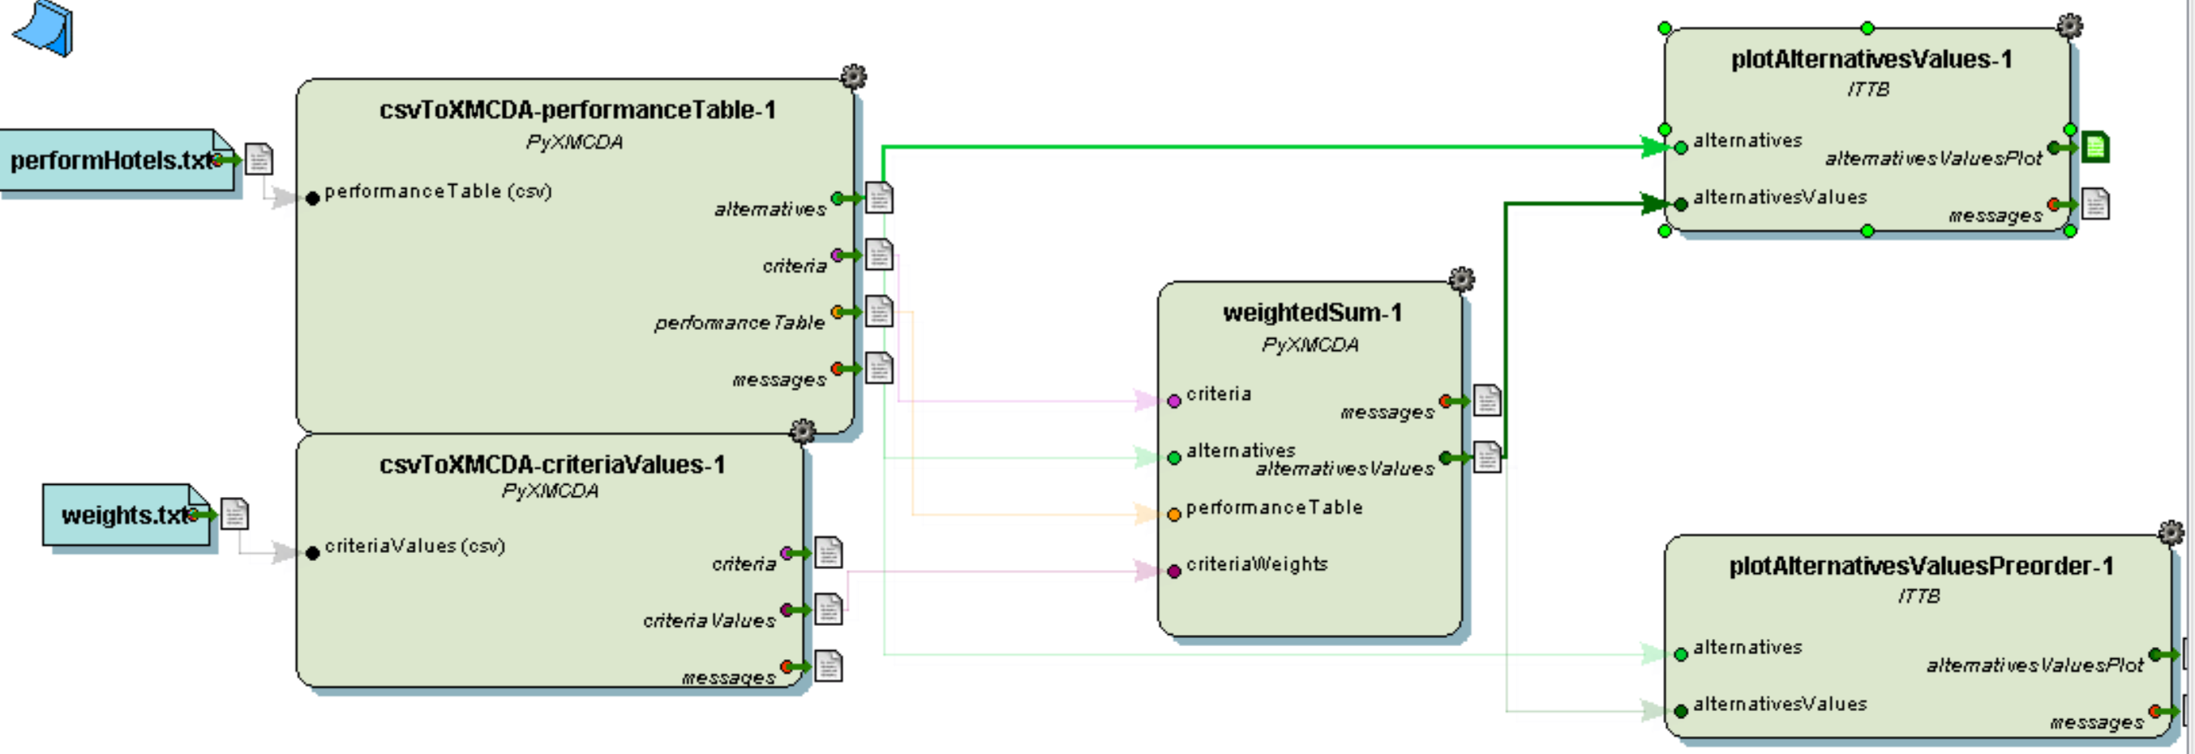

Results

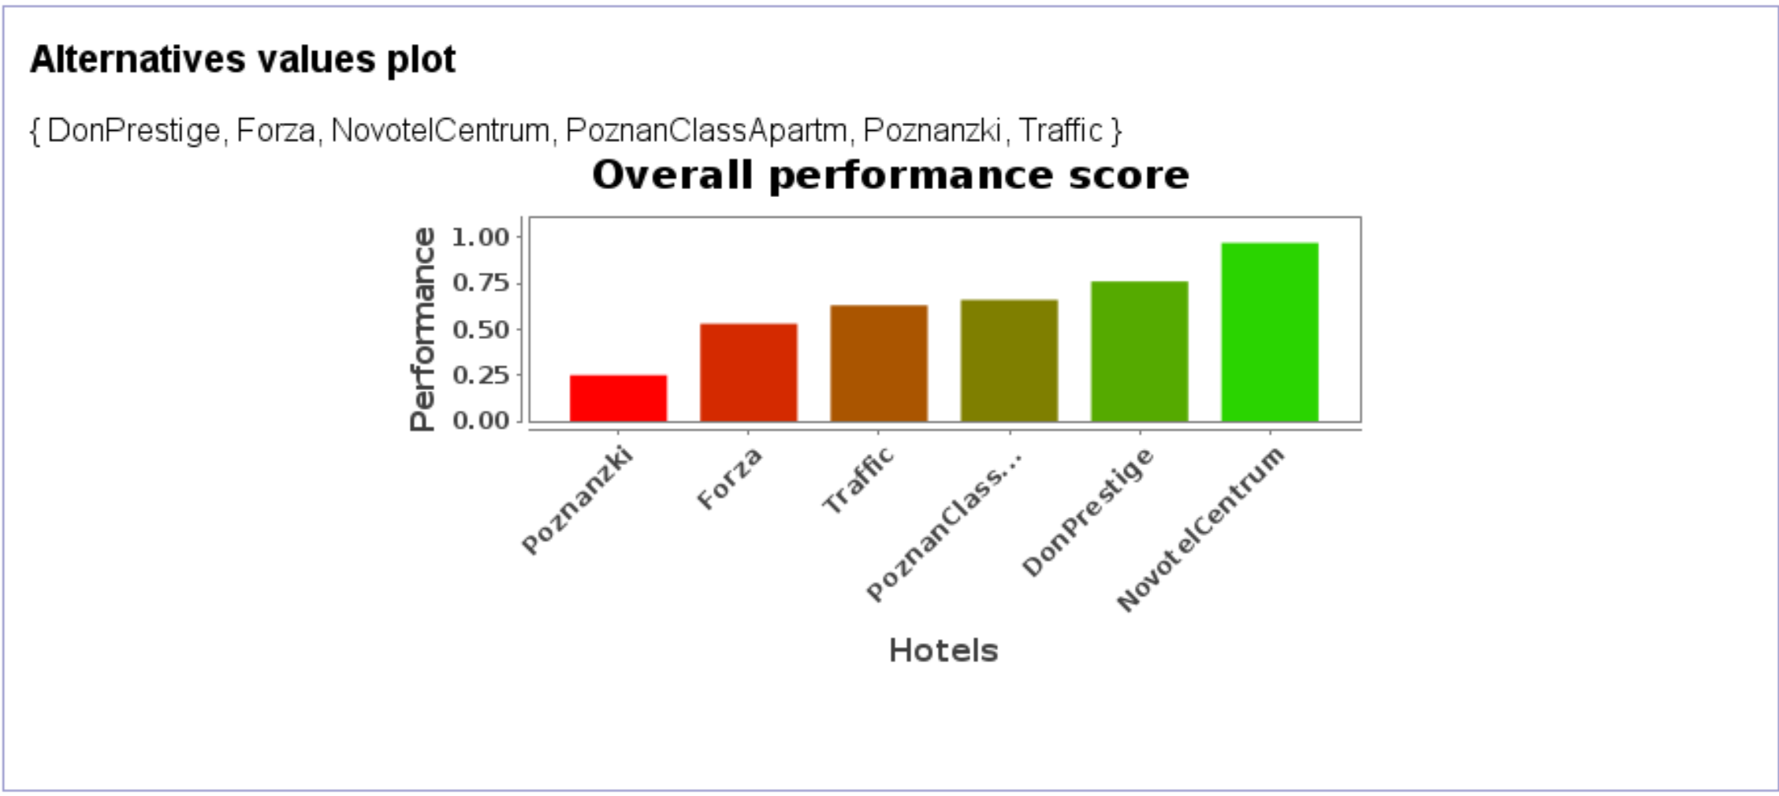

**Alternative Hotel**

Adding a new hotel to the list (ColesHotel), which has poor performance in all but the location criteria, results in NovotelCentrum remaining the top hotel and ColesHotel being second last, with Poznanzki the only hotel performing worse (with a location score of 0).

Hotels and Weight Data

|  |  |  |  |  |
| --- | --- | --- | --- | --- |
| **Hotel** | **Location** | **Stars** | **Facilities** | **Restaurant** |
| Poznanzki | 0 | 0.9 | 0.2 | 0.8 |
| Traffic | 0.7 | 0.6 | 0.7 | 0.1 |
| NovotelCentrum | 1 | 0.7 | 1 | 1 |
| DonPrestige | 1 | 0.1 | 0.8 | 0.3 |
| Forza | 0.2 | 0.9 | 0.7 | 0.8 |
| PoznanClassApartm | 1 | 0.1 | 0.5 | 0.5 |
| ColesHotel | 1 | 0.1 | 0.1 | 0.1 |
| **Weights** | **0.4** | **0.1** | **0.4** | **0.1** |

Workflow

Results

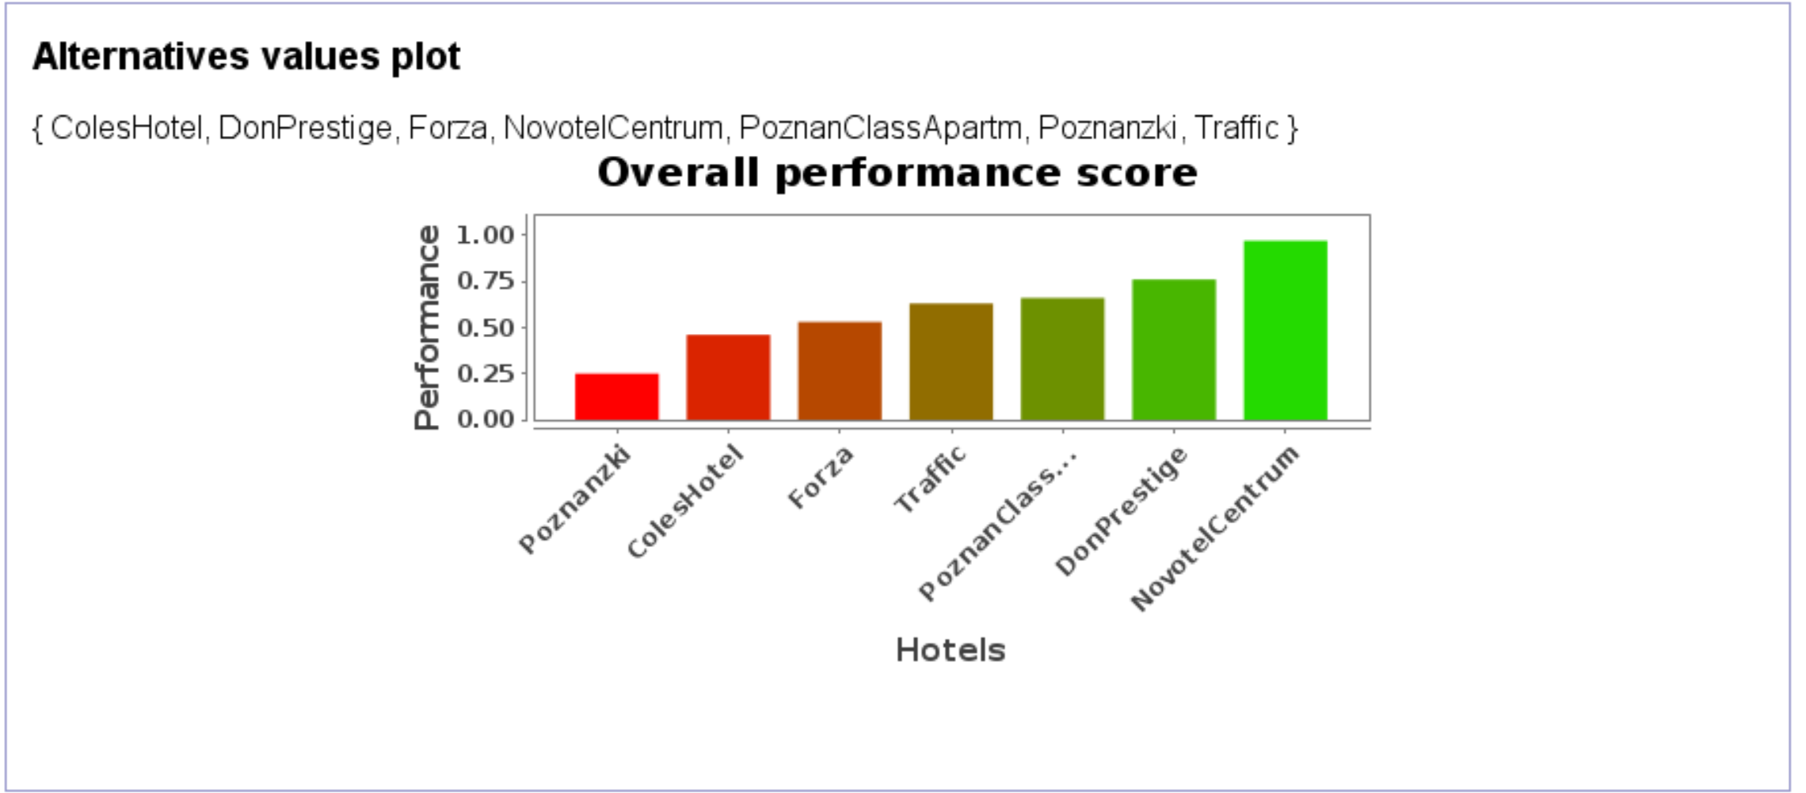

**Weighted vs Arithmetic Average**

Although using either a weighted or arithmetic average does not change the optimal hotel (NovotelCentrum), it does alter the the performance scores and relative ranking of some hotels.

Workflow

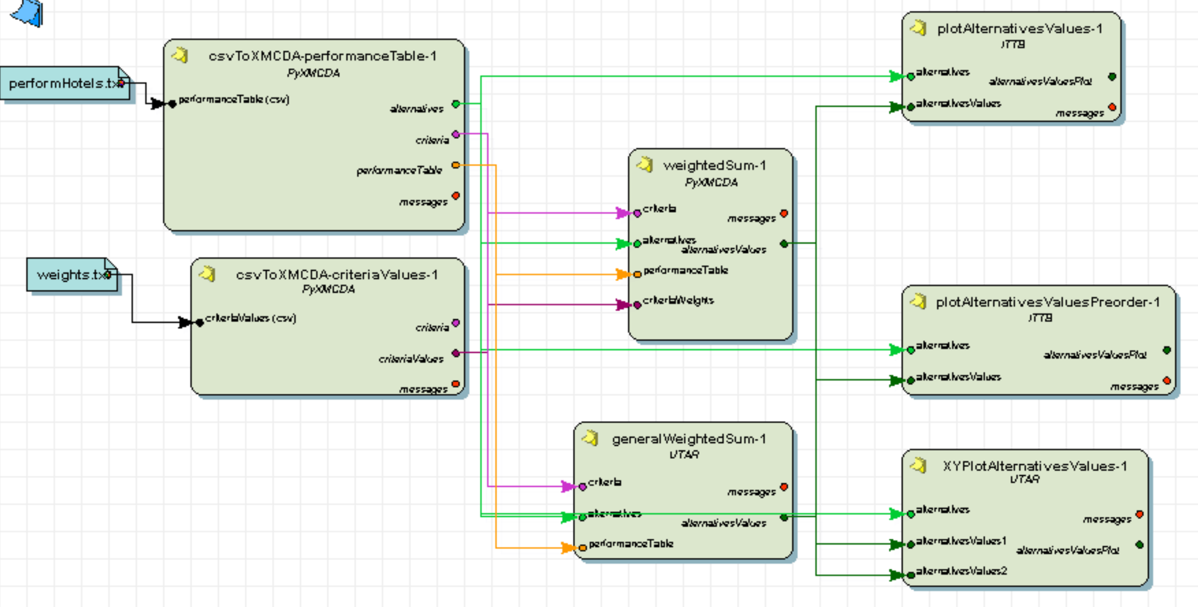

Results

|  |  |  |
| --- | --- | --- |
| **Hotel** | **Weighted Performance** | **Arithmetic Performance** |
| Poznanzki | 0.25 | 0.475 |
| Traffic | 0.63 | 0.525 |
| NovotelCentrum | 0.97 | 0.925 |
| DonPrestige | 0.76 | 0.55 |
| Forza | 0.53 | 0.65 |
| PoznanClassApartm | 0.66 | 0.525 |
| ColesHotel | 0.46 | 0.325 |

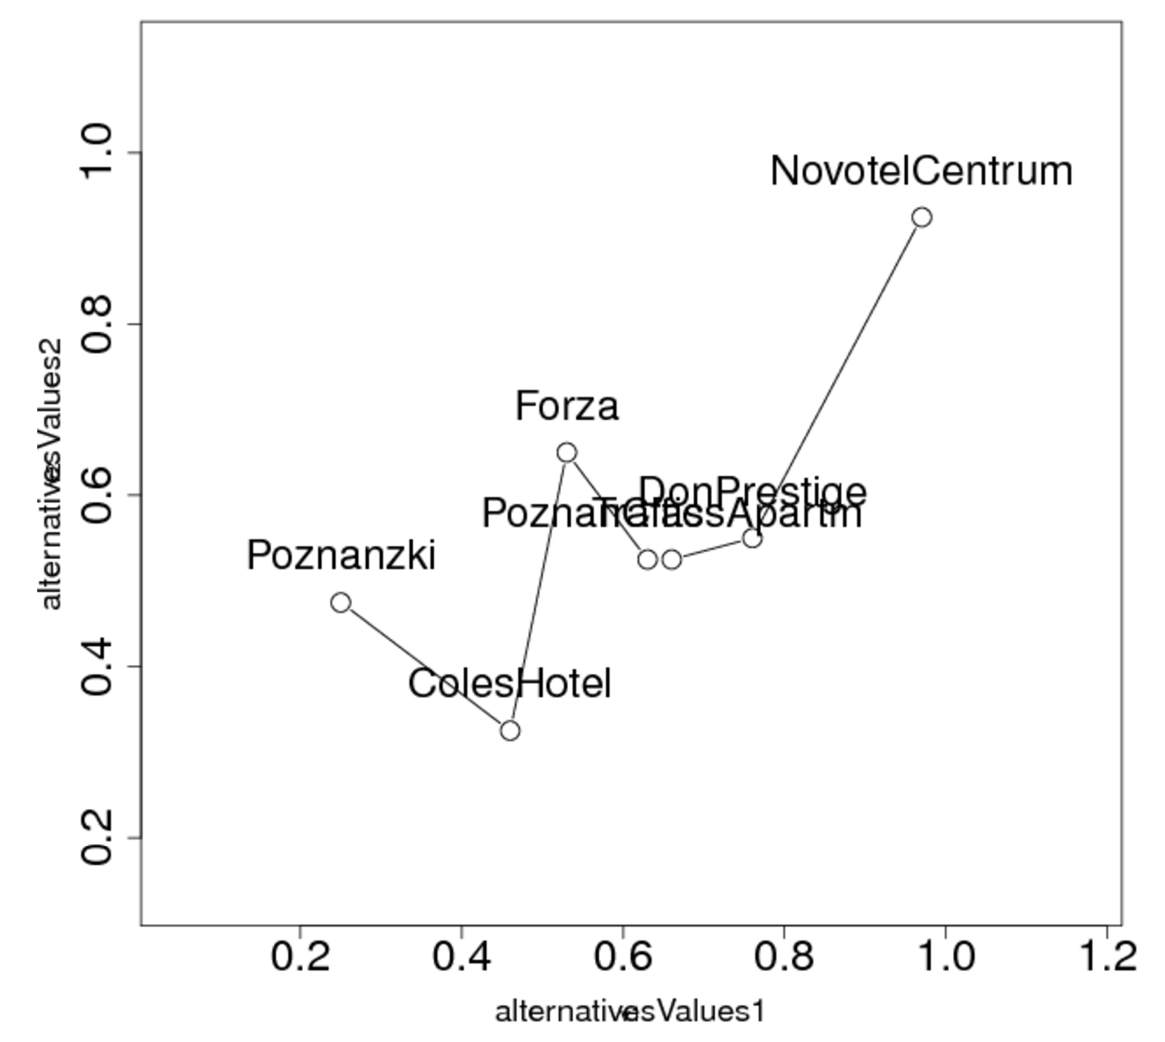

Poznanzki and Forza, two of the worst performing hotels, have increased scores in the purely Arithmetic average performance. The rest of the hotels have their performance scores decrease when using the Arithmetic average performance.

**Ordered Weighted Average**

Using an OWA approach, with ordered weights of 0.1, 0.4, 0.4 and 0.1 results in NovotelCentrum remaining the optimal hotel and ColesHotel being the worst. A neutral aggregation policy is utilized to calculate the performance with the above ordered weights.

Workflow

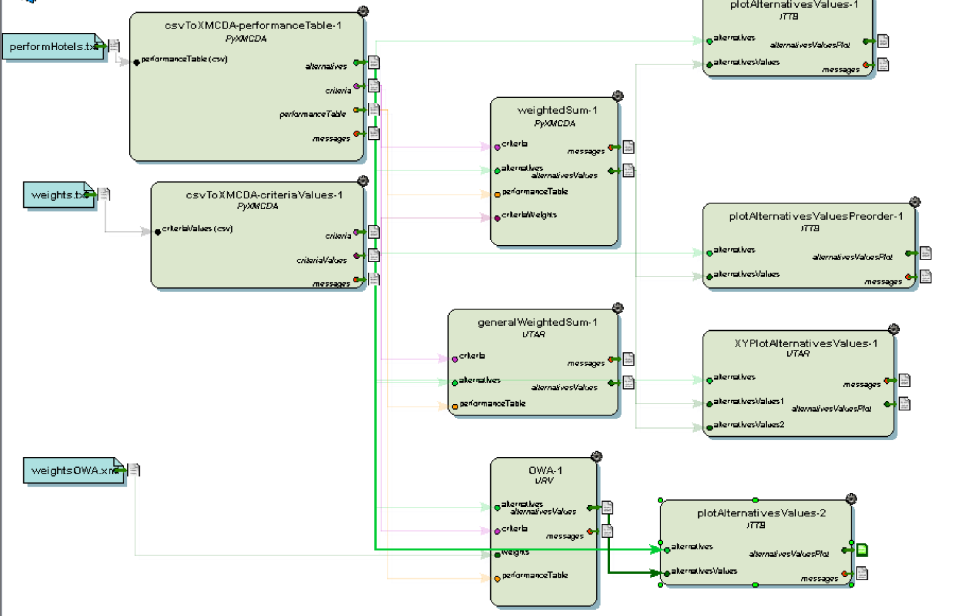

Results

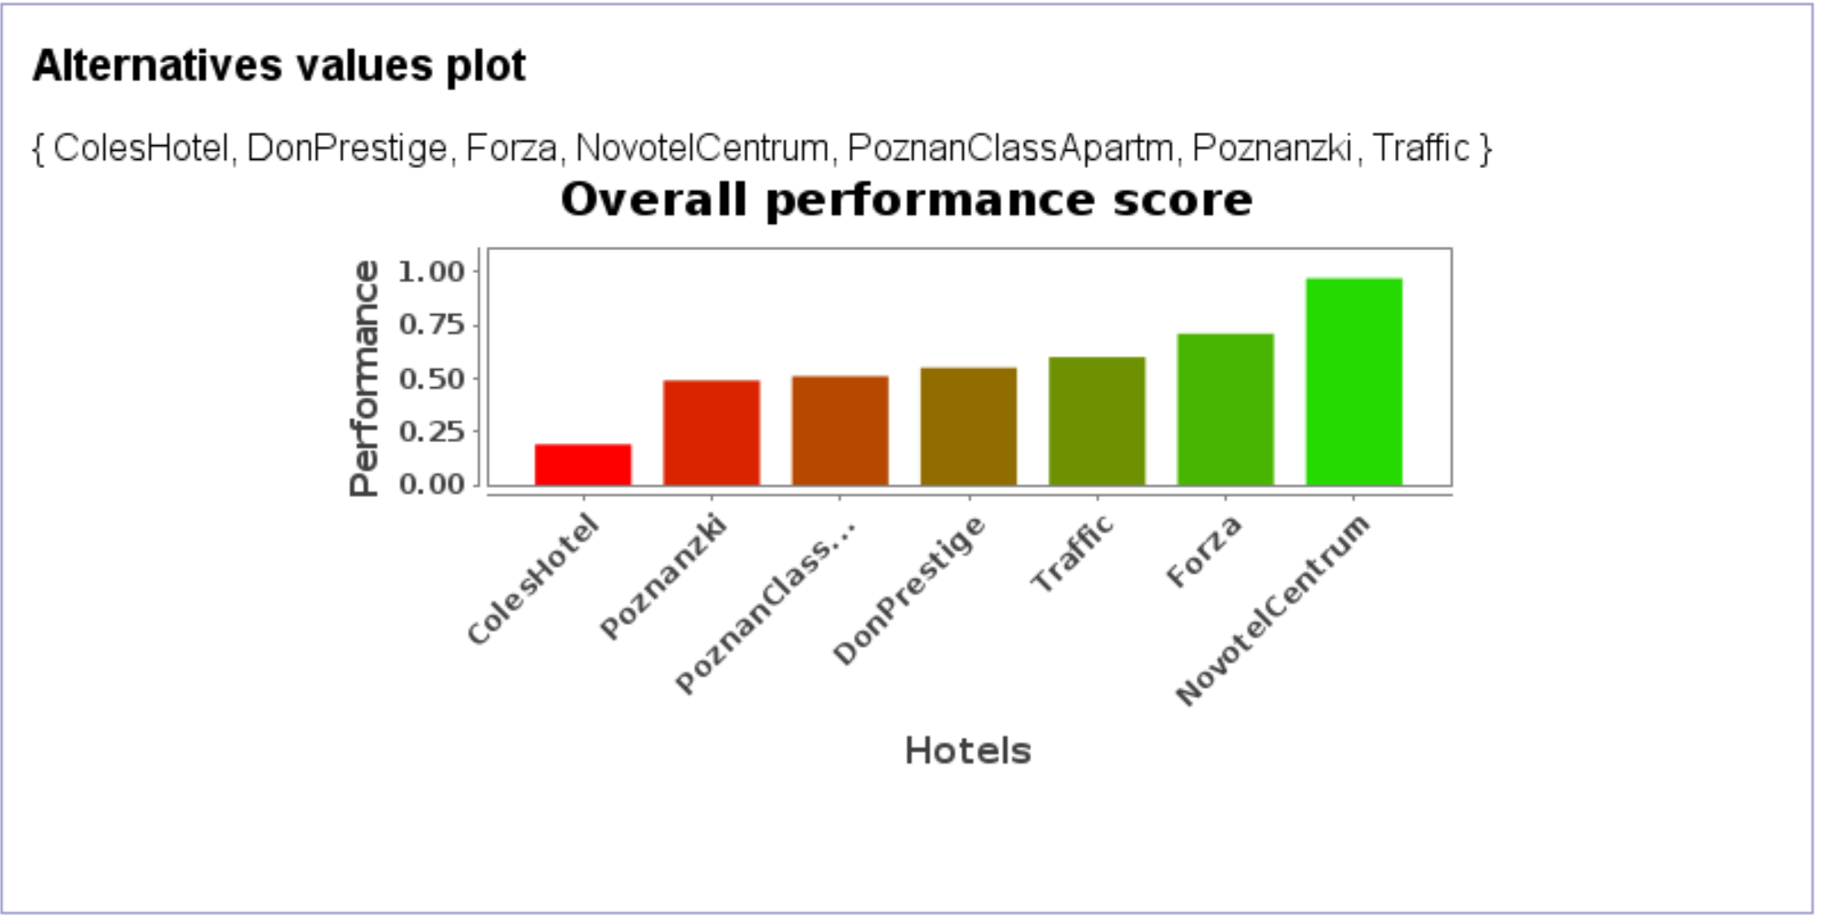

**Disjunctive and Conjunctive OWA**

Workflow

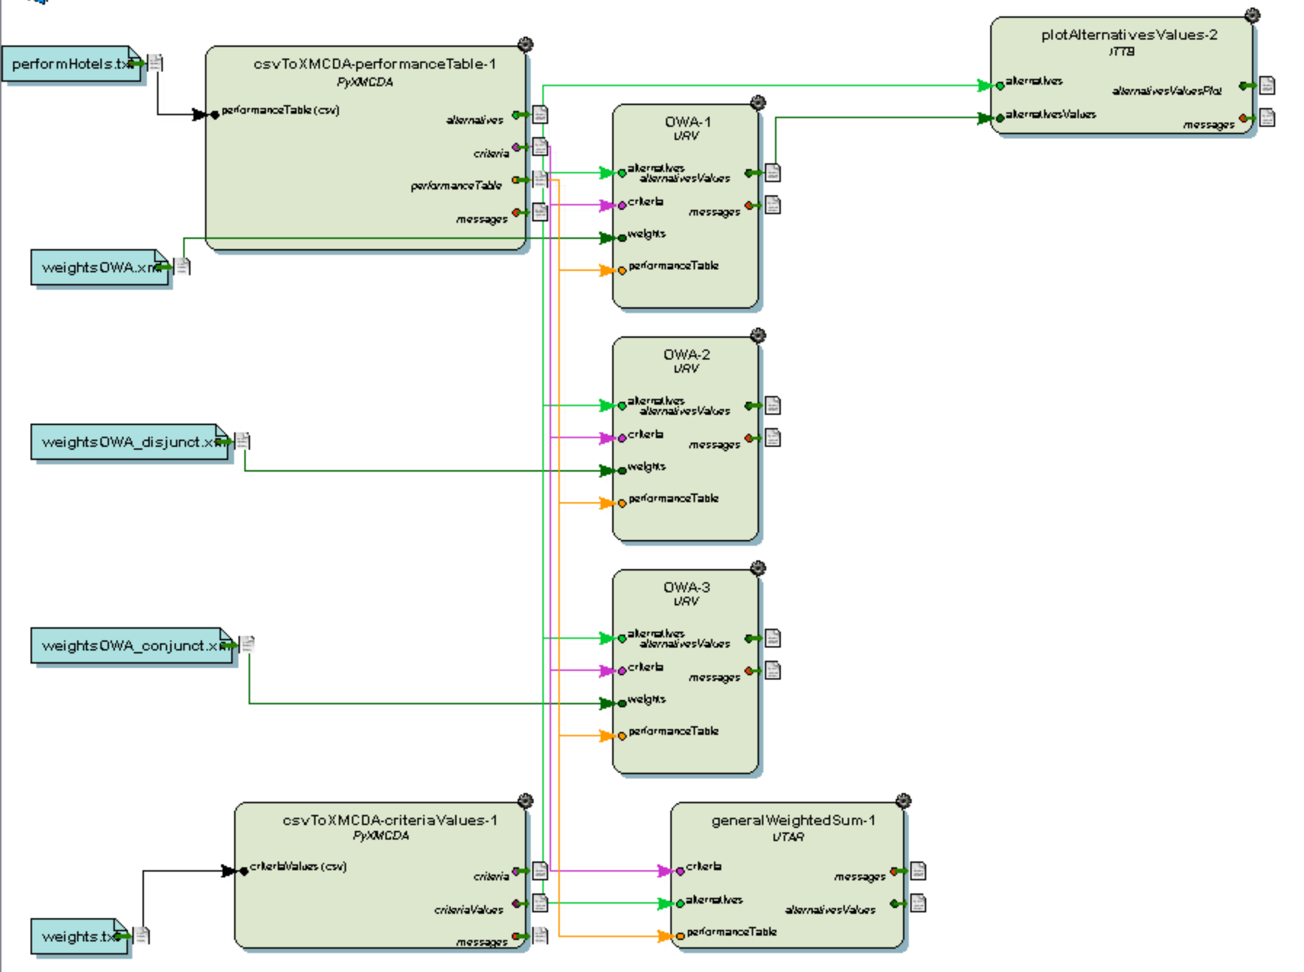

Results

|  |  |  |  |  |
| --- | --- | --- | --- | --- |
| **Hotel** | **Neutral OWA**  **(0.1,0.4,0.4,0.1)** | **Disjunctive OWA**  **(0.5,0.5,0,0)** | **Conjuctive OWA**  **(0,0.3,0.3,0.4)** | **Arithmetic Average** |
| Poznanzki | 0.49 | 0.85 | 0.3 | 0.475 |
| Traffic | 0.6 | 0.7 | 0.43 | 0.525 |
| NovotelCentrum | 0.97 | 1.0 | 0.88 | 0.925 |
| DonPrestige | 0.55 | 0.9 | 0.37 | 0.55 |
| Forza | 0.71 | 0.85 | 0.53 | 0.65 |
| PoznanClassApartm | 0.51 | 0.75 | 0.34 | 0.525 |
| ColesHotel | 0.19 | 0.55 | 0.1 | 0.325 |

With every policy utilized, NovotelCentrum always results in being the optimal hotel. This makes sense given the high scores in each criteria for this hotel. The Conjuctive policy results in much lower performance scores for each hotel, and the Disjunctive policy heavily inflates the performance of each hotel, with NovotelCentrum having a perfect performance with this policy.

**OWA Characterization**

|  |  |  |  |  |
| --- | --- | --- | --- | --- |
| **Weights** | **Balance** | **Divergence** | **Entropy** | **Orness** |
| 0,0.5,0.5,0 | 0 | 0.028 | 0.69 | 0.5 |
| 0,0,0,1 | -1 | 0 | 0 | 0 |
| 0.8,0.2,0,0 | 0.87 | 0.018 | 0.5 | 0.93 |
| 0.2,0.3,0.3,0.2 | 0 | 0.12 | 1.37 | 0.5 |